GEXTON EDUCATION
Summer Internship Program

Movie Rating Analysis
Data Science Task #05

Supervisor: Sir Muhammad Arham MH
June 2025

1. Project Overview
A streaming platform wants to understand which types of movies perform best based on ratings and user reviews. This project performs an end-to-end data science pipeline — cleaning, analysis, and visualisation — to produce actionable insights.

2. Data Source & Methodology

2.1 Dataset
The dataset was constructed for this internship task and contains 26 records (raw) spanning 7 genres from 1984 to 2019. Columns include:
- Movie Name
- Genre
- Release Year
- Rating (1–10)
- Number of Reviews
- Budget in USD (optional field)

2.2 Tools & Libraries
- Python 3 — core programming language
- Pandas — data loading, cleaning, and transformation
- NumPy — numerical operations
- Matplotlib & Seaborn — data visualisation
- VS Code — development environment

2.3 Pipeline
- Data Cleaning — handle missing values, remove duplicates, enforce data types
- Basic Analysis — descriptive statistics, genre averages, most-reviewed titles
- Data Visualisation — three charts (bar, horizontal bar, histogram)
- Insights — short report summarising findings

3. Data Cleaning
The raw dataset presented three quality issues that were resolved before analysis:

Issue | Detail | Resolution
1 Duplicate row | Gone Girl appeared twice | drop_duplicates() removed 1 row
2 Missing Ratings | Superbad & The Witch had no rating | Rows dropped (required field)
4 Missing Budgets | Budget is an optional column | Filled with 0 (flagged unknown)
Incorrect dtypes | Year stored as float | Cast to int for all numeric cols

After cleaning, the working dataset contained 23 movies across 7 genres, with all data types correctly assigned.

4. Basic Analysis

23  Movies Analysed | 7  Genres Covered | 8.11  Average Rating | 1984–2019  Year Range

4.1 Highest-Rated Movie
The Shawshank Redemption (1994) holds the highest rating of 9.3 out of 10, and is simultaneously the most-reviewed title with 2.8 million reviews — a rare combination of critical acclaim and audience engagement.

4.2 Genre-Wise Average Ratings

Genre | Avg Rating | Rank
Drama | 8.80 | #1
Action | 8.37 | #2
Sci-Fi | 8.25 | #3
Thriller | 8.10 | #4
Romance | 7.93 | #5
Horror | 7.57 | #6
Comedy | 7.50 | #7

4.3 Top 5 Most-Reviewed Movies

# | Movie | Reviews
1 | The Shawshank Redemption | 2,800,000
2 | The Dark Knight | 2,500,000
3 | Inception | 2,100,000
4 | Forrest Gump | 1,900,000
5 | Interstellar | 1,800,000

5. Data Visualisation

Chart 1 – Genre vs Average Rating
This bar chart compares the average movie rating across all seven genres. Drama dominates with an average of 8.80, while the dashed red line marks the overall average of 8.11 for easy benchmarking.
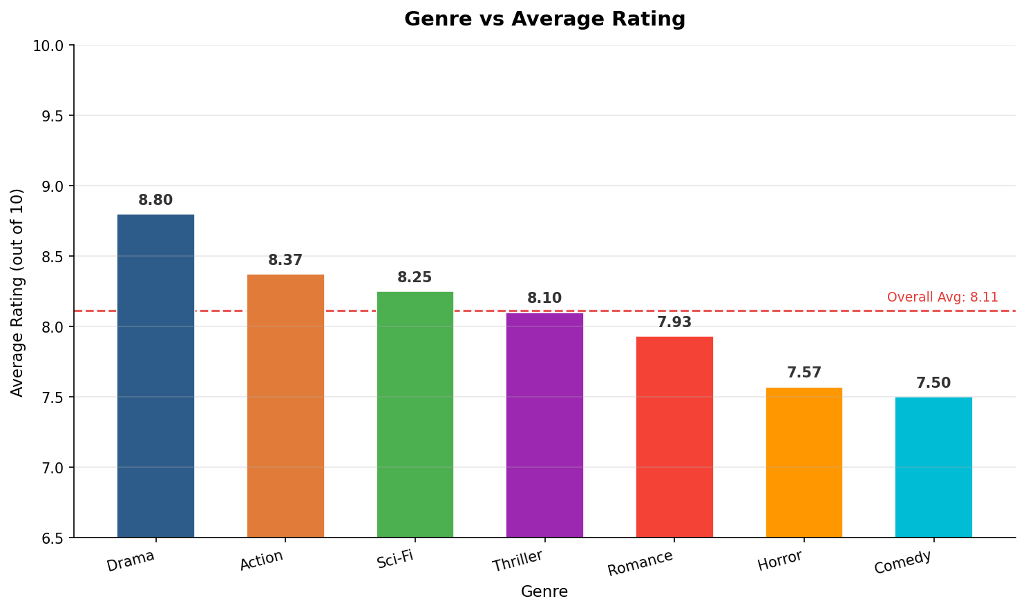

Chart 2 – Top 5 Movies by Rating
The horizontal bar chart ranks the five highest-rated films. The Shawshank Redemption leads at 9.3, followed by Inception (8.8) and Forrest Gump (8.8). All top-5 titles are Drama or Sci-Fi, reinforcing genre-level findings.
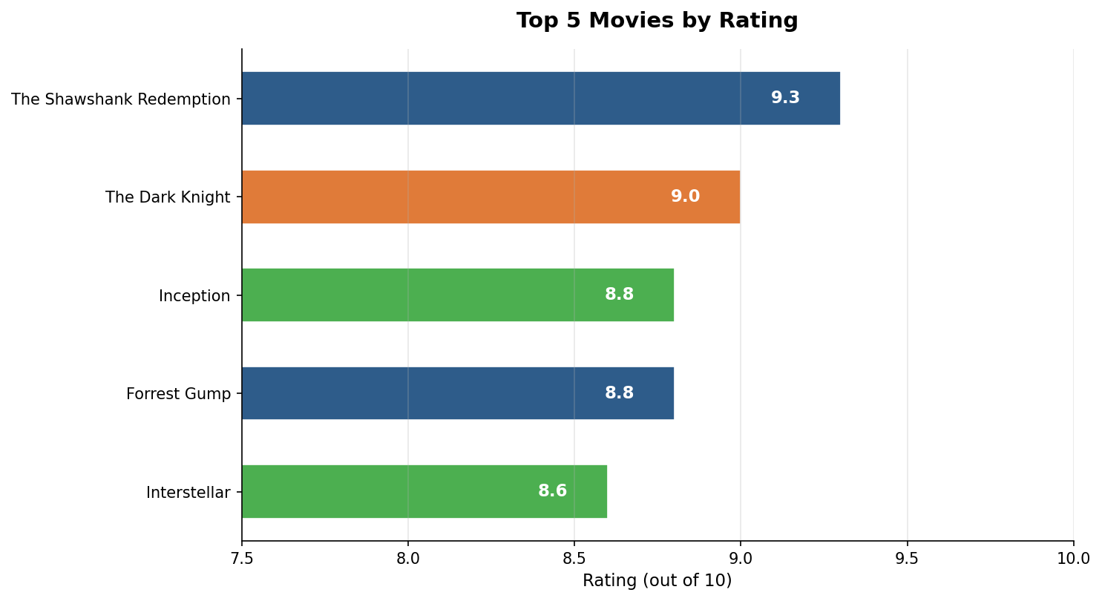

Chart 3 – Rating Distribution
The histogram reveals that ratings are right-skewed — most movies cluster between 7.5 and 9.0, with mean (8.11) and median (8.10) nearly identical. Very few films fall below 7.5, indicating a high-quality library overall.
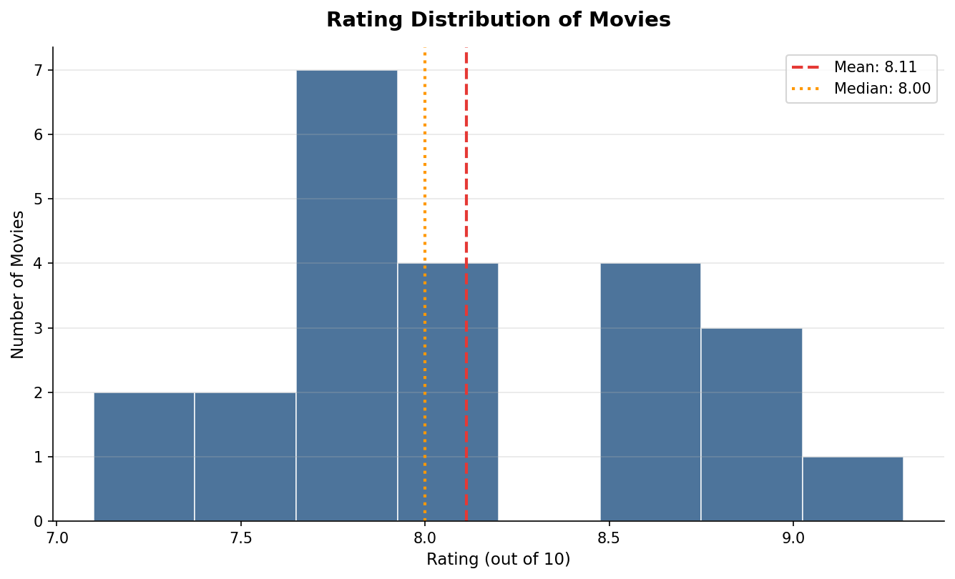

6. Insights

6.1 Which Genre Performs Best?
Drama is the clear leader with an average rating of 8.80, propelled by landmark titles such as The Shawshank Redemption (9.3), Parasite (8.6), and Forrest Gump (8.8). Action and Sci-Fi follow closely at 8.37 and 8.25 respectively. Comedy and Horror rank lowest at 7.50 and 7.57, suggesting these genres are more variable in audience reception.

6.2 Do High-Budget Movies Get Better Ratings?
Films with budgets exceeding USD 100 million averaged 8.40, compared to 8.06 for lower-budget productions — a gap of just 0.34 points. This modest difference suggests that budget is not the primary driver of ratings. Smaller-budget films like Parasite (USD 11.4M, rated 8.6) and Get Out (USD 4.5M, rated 7.7) demonstrate that strong storytelling and direction can rival or outperform blockbuster productions.

6.3 Overall Performance Trend
The dataset's overall average of 8.11 with a standard deviation of only 0.57 indicates a consistently high-quality film collection. Ratings are tightly clustered between 7.5 and 9.0, with very few outliers. Classic films from the 1990s hold dominant positions in the top tier, while recent releases such as Parasite (2019) and Knives Out (2019) confirm that top-tier cinema continues to emerge across decades. The streaming platform should prioritise Drama and Sci-Fi genres for catalogue expansion, as these genres demonstrate the highest and most consistent audience satisfaction.

7. Deliverables
- movies_raw.csv — original dataset (26 records)
- movies_cleaned.csv — cleaned dataset (23 records)
- movie_analysis.py — full analysis pipeline script
- movie_rating_analysis.ipynb — Jupyter Notebook
- chart1_genre_avg_rating.png — Genre vs Average Rating bar chart
- chart2_top5_movies.png — Top 5 Movies horizontal bar chart
- chart3_rating_distribution.png — Rating Distribution histogram
- README.md / README.txt — project documentation

